**MCQ based Academic Task-1**

**Course code: INT306 Section: E1909/E2013**

**Total Duration: 40 mins No negative marking**

**Date: 20-09-2021**

1. Department (dept name, building, budget) and Employee (employee_id , name, dept name,salary)  
Here the dept_name attribute appears in both the relations .Here using common attributes in relation schema is one way of relating ___________ relations.  
a) Attributes of common  
b) Tuple of common  
**c) Tuple of distinct**  
d) Attributes of distinct

2. Given the basic ER and relational models, which of the following is INCORRECT?

A. An attribute of an entity can have more than one value

B. An attribute of an entity can be composite

**C. In a row of a relational table, an attribute can have more than one value**

D. In a row of a relational table, an attribute can have exactly one value or a NULL value

3. Consider the following ER diagram. The minimum number of tables needed to represent M, N, P, R1, R2 is ______.

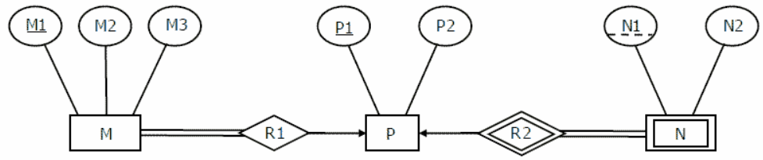

A. 2

**B. 3**

C. 4

D. 5

4. Which one of the following given statements possibly contains the error?

a. select * from emp where empid = 10003;

b. select empid from emp where empid = 10006;

c. select empid from emp;

**d. select empid where empid = 1009 and Lastname = 'GELLER'**;

5. Which of the following refers to the level of data abstraction that describes exactly how the data actually stored?

a. Conceptual Level

**b. Physical Level**

c. File Level

d. Logical Level

6. Drop Table cannot be used to drop a Table referenced by __________ constraint.

(i) Primary key

(ii) Sub key

(iii) Super key

(iv) Foreign key

A. i

B. i, ii and iii

**C. iv**

D. i and iv

7. What kind of mechanism is to be taken into account for converting a weak entity set into strong entity set in entity-relationship diagram?

A. Generalization

B. Aggregation

C. Specialization

**D. Adding suitable attributes**

8. Which of the following are TCL commands?

**a. COMMIT and ROLLBACK**

b. UPDATE and TRUNCATE

c. SELECT and INSERT

d. GRANT and REVOKE

9. Which of the following statement is true?

**a. TRUNCATE free the table space while DELETE does not.**

b. Both TRUNCATE and DELETE statements free the table's space.

c. Both TRUNCATE and DELETE statement does not free the table's space.

d. DELETE free the table space while TRUNCATE does not.

10. Which of the following is the right command if you want to display only the first 4 rows of the ‘Employee_Data’ table?

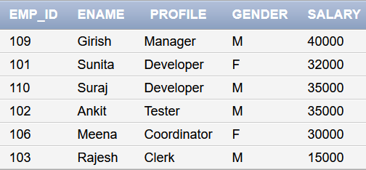

a. SELECT * from Employee_Data WHERE ROWNUMBER <= 4

b. SELECT * from Employee_Data WHERE ROW <= 4

**c. SELECT * from Employee_Data WHERE ROWNUM <= 4**

d. SELECT * from Employee_Data WHERE ROWS <= 4

11. How can you change "Sharma" into "Kumar" in the "LastName" column in the Users table?

a. UPDATE User SET LastName = 'Sharma' INTO LastName = 'Kumar'

b. MODIFY Users SET LastName = 'Kumar' WHERE LastName = 'Sharma'

c. MODIFY Users SET LastName = 'Sharma INTO LastName = 'Kumar'

d. UPDATE Users SET LastName = 'Kumar' WHERE LastName = 'Sharma'

12. Which of the following options are Right regarding these three keys (Primary Key, Super Key, and Candidate Key) ?

I. Only one candidate key can be a primary key

II. Minimal super key is a candidate key.

III. All super keys can be a candidate key

IV. We cannot find a primary key from the candidate key

**a. I and II**

b. II and III

c. I and III

d. II and IV

13. Which of the following wildcards is used to “Sets and ranges of characters to match” in a string while working with SQL Like clause?

a. %

b. _

**c. []**

d. $

14. In which of the following cases a DML statement is not executed?

a. When existing rows are modified.

**b. When a table is deleted.**

c. When some rows are deleted.

d. When some rows are dropped

15. ______ is NOT a type of constraint in SQL language?

a. FOREIGN KEY

b. PRIMARY KEY

c. UNIQUE

**d. ALTERNATE KEY**